Item Transfer
Moving stock from one warehouse to another
Fuse Manufacturing — user guide 02

Before you start

What this job is
An Item Transfer records stock physically moving from one warehouse to another. Nothing is bought, sold, made or thrown away — the same stock is simply somewhere else afterwards.
Some everyday examples: a drum of process oil goes from the Johannesburg store to Cape Town; finished tread is moved from the factory to dispatch; raw material is brought from the main store into a smaller working store.
If the stock is going to the factory floor to be used in production, use Issue to WIP instead — it is the same idea but it is worth keeping those movements separate so you can see what is out on the floor.

What a warehouse means here
A warehouse in Fuse is any place stock can sit. That includes stores, dispatch areas, consignment locations and work-in-progress areas on the factory floor. Every warehouse comes from Sage Intacct — you cannot create one in Fuse, and you should not try.
Warehouse names follow a pattern: the site, then the area, then the company suffix. For example, JHB Industria - Dispatch - LRC. The last part, LRC, is Leader Rubber Company and appears on every warehouse.

Two things that are always true
- You can only move stock that is actually there. Fuse will not let you move 500 kg out of a warehouse holding 200 kg.
- The source and target must be different. Moving stock to where it already is means nothing, and Fuse will stop you.

Why this matters
Fuse and Sage Intacct hold the same stock figures. When you submit a transfer, Fuse sends it to Intacct first and only records it here once Intacct has accepted it. That is why you never have to enter the same movement twice, and why the two systems cannot drift apart.

Doing the transfer
The whole job is six pieces of information: where it is coming from, where it is going, what it is, how much, and then save and submit. Everything else on the screen can be left alone.

Step 1 — Open the transfer screen
- Item TransferOn the Fuse Home screen, find the
- tile — third along, with the two arrows. Click anywhere on the tile.
If you are not on Fuse Home, click the F button in the green bar at the top of the screen, or Fuse Home in the list down the left.
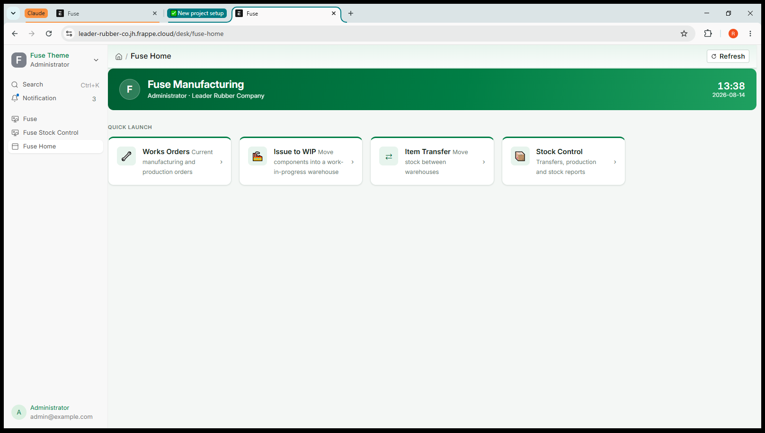
Screenshot 1 — The Fuse Home screen, showing the four tiles
A new blank form opens, titled New Stock Entry. Along the top you will see the words Not Saved in orange — that is normal, and simply means you have not saved yet.
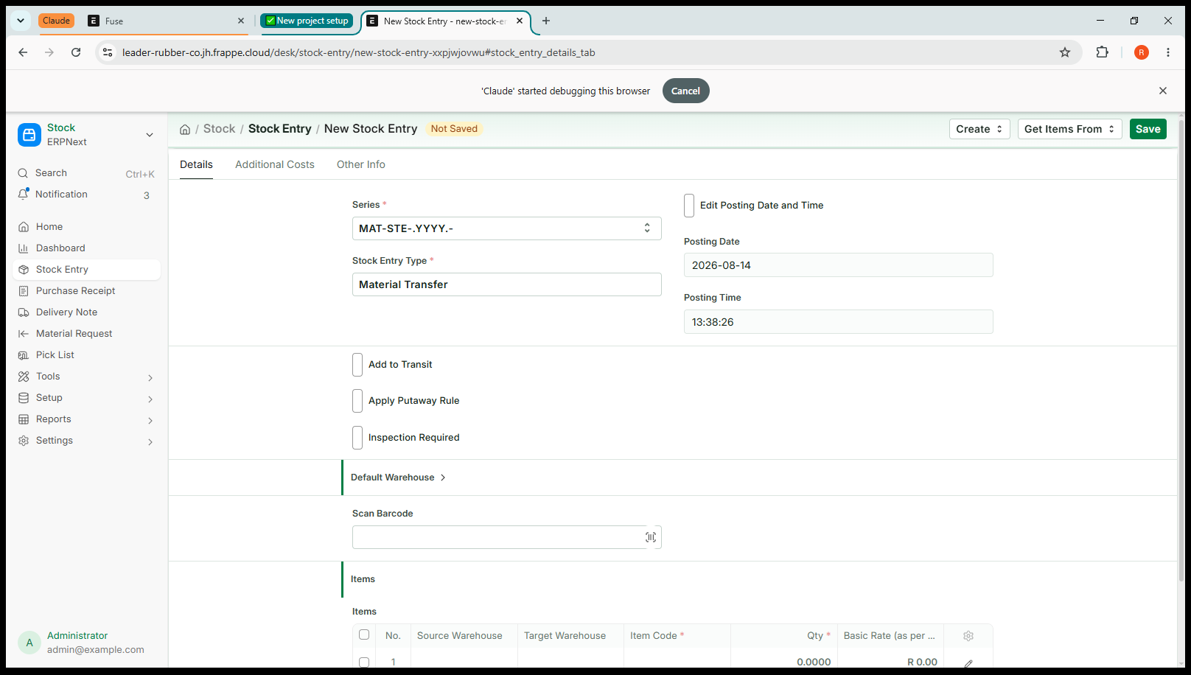
Screenshot 2 — A new, empty Item Transfer

Step 2 — Check the top of the form
Two fields are already filled in for you. Read them, but do not change them unless the instruction below says so.

Field | What it is, and what to do
Series | The numbering pattern for the document. Leave it exactly as it is.
Stock Entry Type | Already says Material Transfer, because you came in through the Item Transfer tile. If it says anything else, close the form and start again from the tile.
Posting Date | Today's date. Change it only if you are recording a movement that physically happened on an earlier day.
Posting Time | The time now. Leave it.

You may also see tick boxes named Add to Transit, Apply Putaway Rule and Inspection Required, and sections named Default Warehouse and Scan Barcode. Leave all of them alone. They are for other ways of working that Leader Rubber does not use.

Step 3 — Fill in the first line
Scroll down to the section headed Items. There is a table with one empty row, numbered 1. Each row is one item being moved. You will fill in four boxes across that row.
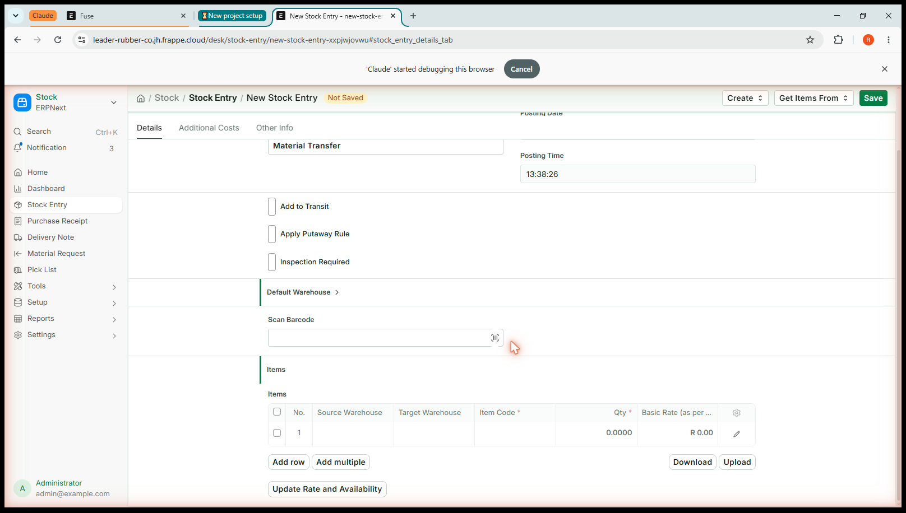
Screenshot 3 — The empty Items table
Click directly into the box under Source Warehouse on row 1. The row opens up for editing and a list appears below it.

Step 4 — Choose the warehouses
- Source Warehouse: Type the first few letters of the warehouse you are taking stock
- from. A list appears underneath as you type.
- Click the warehouse you want in that list. Do not just type the name and move on.
- The search is loose — typing JHB Industria - Dis will also offer Cape Town - Dispatch and Fuse_WIP_Process1. Always read the list and click the right one.
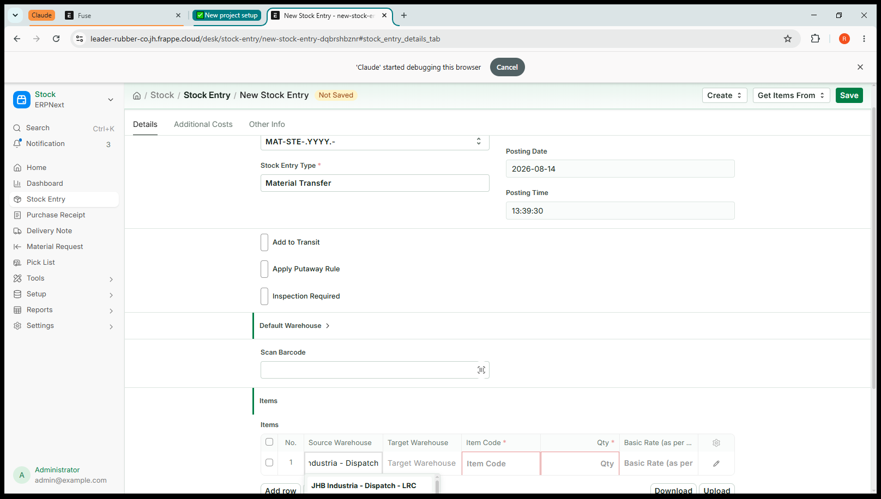
Screenshot 4 — Choosing a warehouse from the list
- Target Warehouse: Do the same in the next box for where the stock is going.

A common slip
Typing a warehouse name and pressing Tab without clicking an entry in the list leaves the box empty. If a warehouse box looks blank after you have typed in it, that is what happened — click into it and pick from the list.

Step 5 — Choose the item and the quantity
- Item Code: Click into the Item Code box. Type part of the item code or part of its description — either works. Pick the right one from the list.
- Qty: Type how much is moving. Use the item's own unit — kilograms for compound, each for a moulded part. You do not choose the unit; Fuse uses whatever the item is measured in.
You may see a column called Basic Rate showing a value. Leave it. Fuse works the value out from what the stock is already worth; you never price a transfer.
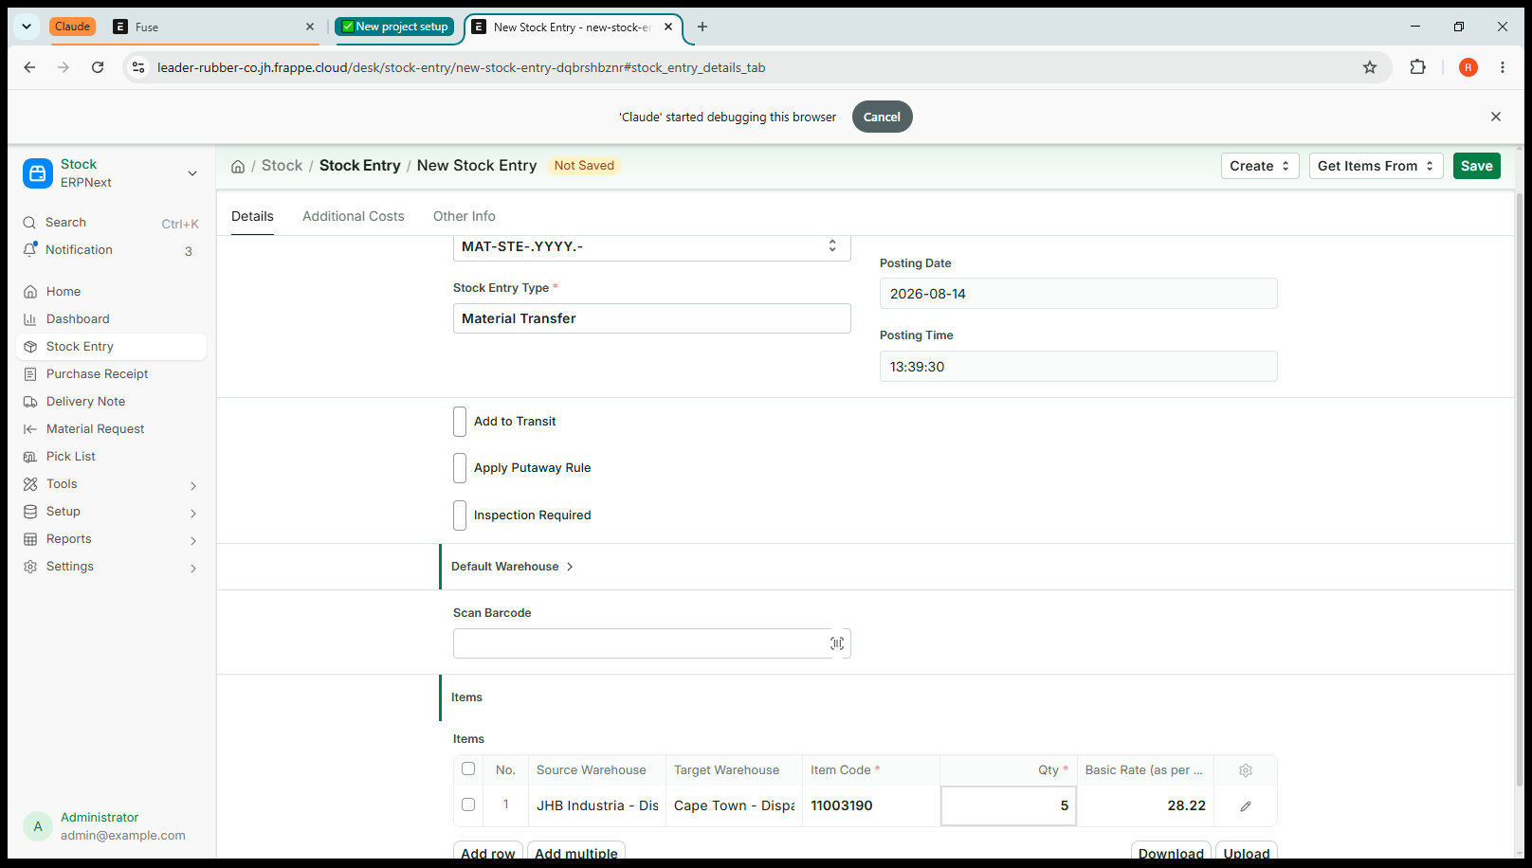
Screenshot 5 — A completed line

Step 6 — Add any more items
One transfer can carry as many items as you like, and each row can use different warehouses. If a lorry is taking six items from Johannesburg to Cape Town, that is one transfer with six rows — not six transfers.
- Click Add row underneath the table.
- Fill in the new row the same way.
- Repeat until every item on the move is listed.
To remove a row you added by mistake, tick the box on the left of that row and choose the delete option that appears.

Step 7 — Save
- Click the Save button at the top right of the screen.
The document is now saved as a draft. It has been given a number — something like MAT-STE-2026-00012 — and the orange Not Saved has gone.
Nothing has moved yet. A draft changes no stock at all, in Fuse or in Intacct. You can leave it, come back later, or correct it as much as you like.
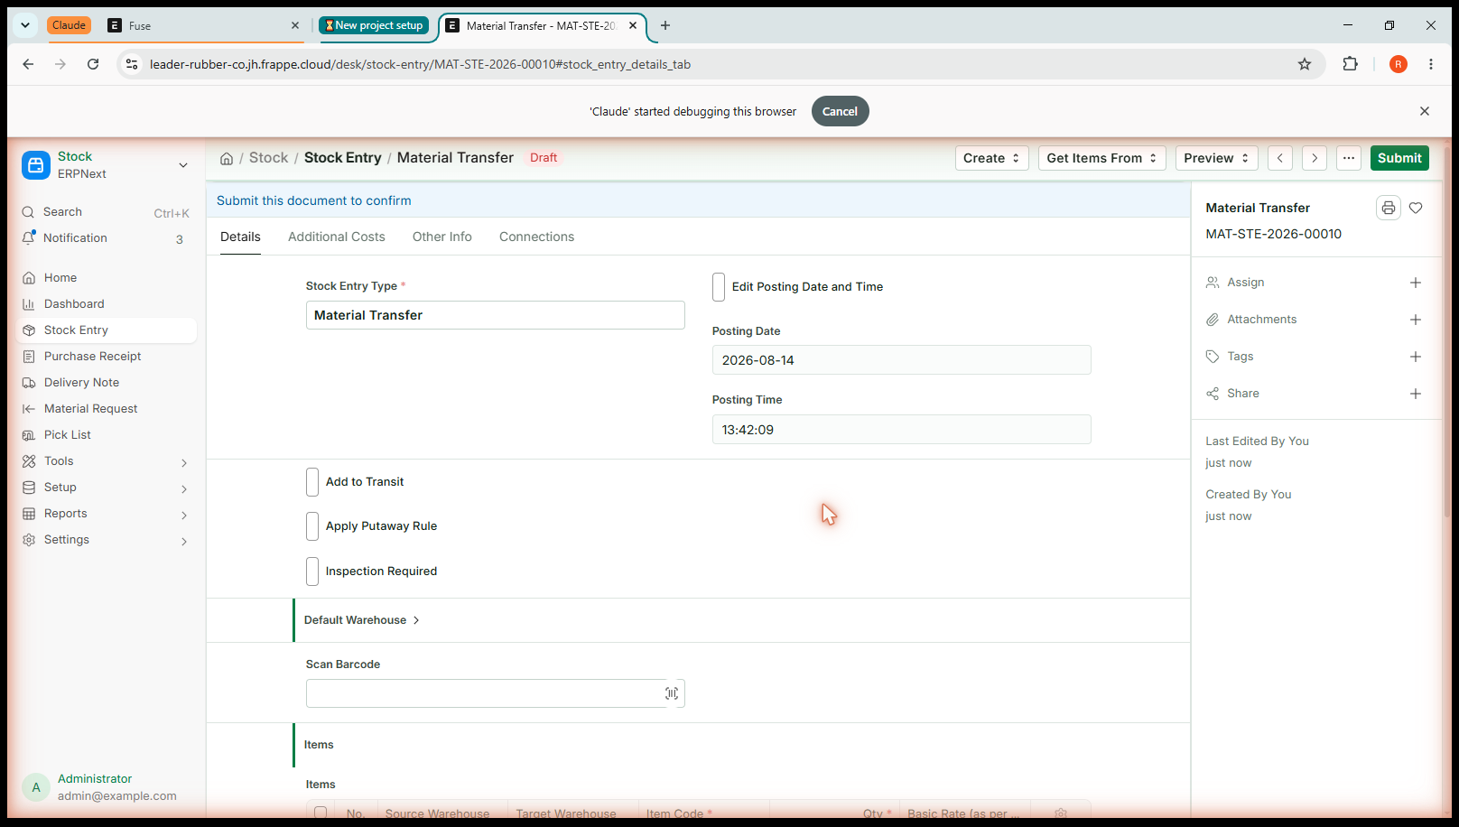
Screenshot 6 — The saved draft

Step 8 — Check it, then submit
This is the last point at which changing your mind is free. Read the lines once more, against the paperwork or the pallet in front of you:
- Is the stock really coming out of that warehouse?
- Is it really going to that one?
- Is the quantity right, in the right unit?
- When you are satisfied, click Submit at the top right.
- Confirm when Fuse asks whether you are sure.

What happens the moment you submit
Fuse sends the transfer to Sage Intacct. Intacct records the stock leaving the source warehouse and arriving at the target, and sends back its reference. Only then does Fuse record the movement here. If Intacct refuses it, nothing is saved in either system and you will see the reason on screen.

Checking it worked
A submitted transfer shows the status Submitted at the top of the screen, and the document can no longer be edited. That is the sign that both systems have accepted it.
To see the effect on stock:
- Go to Fuse Home and click Stock Control.
- Under Reports, open Stock Balance.
- Filter to the item you moved. The source warehouse should be lower by the quantity you moved, and the target warehouse higher by the same amount.
Under the Transfers shortcut on that same screen you will find every transfer that has been recorded, including the one you just did.

If something goes wrong
Fuse would rather stop you than record something wrong. A message on a red or orange background means nothing has been saved — read it, fix that one thing, and try again.

What you see | What it means and what to do
Source and destination are the same warehouse | Both boxes on a row point at the same place. Correct one of them.
Quantity must be positive | A quantity is zero, blank or negative. Enter how much is moving as a positive number; to move stock back the other way, do another transfer.
Negative stock / not enough quantity | The source warehouse does not hold that much. Check the figure in Stock Balance, or check you have the right warehouse.
Warehouse … has no Intacct Warehouse ID | The warehouse is not one Intacct knows about. Do not work around it — tell your administrator, as something is out of step between the two systems.
Intacct rejected the request | Intacct would not accept the movement, and the reason from Intacct follows the message. Nothing has been recorded anywhere. If the reason is not something you can fix, send the message to your administrator.

If you make a mistake after submitting
Mistakes happen and there is a proper way to undo one. Do not try to fix it with a second transfer going the other way — that leaves two wrong movements in the history instead of none.
- Open the transfer. You can find it under Stock Control, then Transfers.
- Click Cancel at the top right.
- Confirm.
Fuse reverses the movement in Intacct first, then cancels the document here. Both systems return to exactly where they were, and the record of what happened and what undid it is kept.

Do not delete
Cancelling and deleting are not the same thing. Cancelling reverses the movement properly and leaves an audit trail. Deleting would remove the record while Intacct still holds the movement, and the two systems would disagree from that point on.

Practise it
Before you do this for real, try the whole thing once on the training system. A good first exercise:
- Use Stock Control, then Stock Balance, to find an item that has stock in two warehouses. Write down both figures.
- Transfer a small quantity — five of something — from one to the other.
- Go back to Stock Balance and check both figures moved by exactly that amount.
- Now cancel the transfer, and check the figures return to what you first wrote down.
Once you have done that and the numbers behave the way you expect, you understand the job well enough to do it live.

Quick reference
Fuse Home → Item Transfer → fill the row → Save → check → Submit.

Question | Answer
Can I move several items at once? | Yes. Add a row for each. They can use different warehouses.
Do I set the price? | No. Fuse uses what the stock is already worth.
Do I choose the unit? | No. Fuse uses the item's own unit.
Does saving move stock? | No. Only submitting does.
Can I edit after submitting? | No. Cancel it and do a new one.
Do I need to tell Intacct? | No. Fuse sends it as you submit.
Can I receive supplier goods here? | No. Goods receipting is done in Intacct.
Can I adjust stock up or down here? | No. That is a Cycle Count in Intacct.

